**CS4780 – 1**

**PROJECT 1**

**Simplified DES Block cipher**

Brij Shah

305436344

Hitarth Shah

305084889

**Part - 1 SDES**

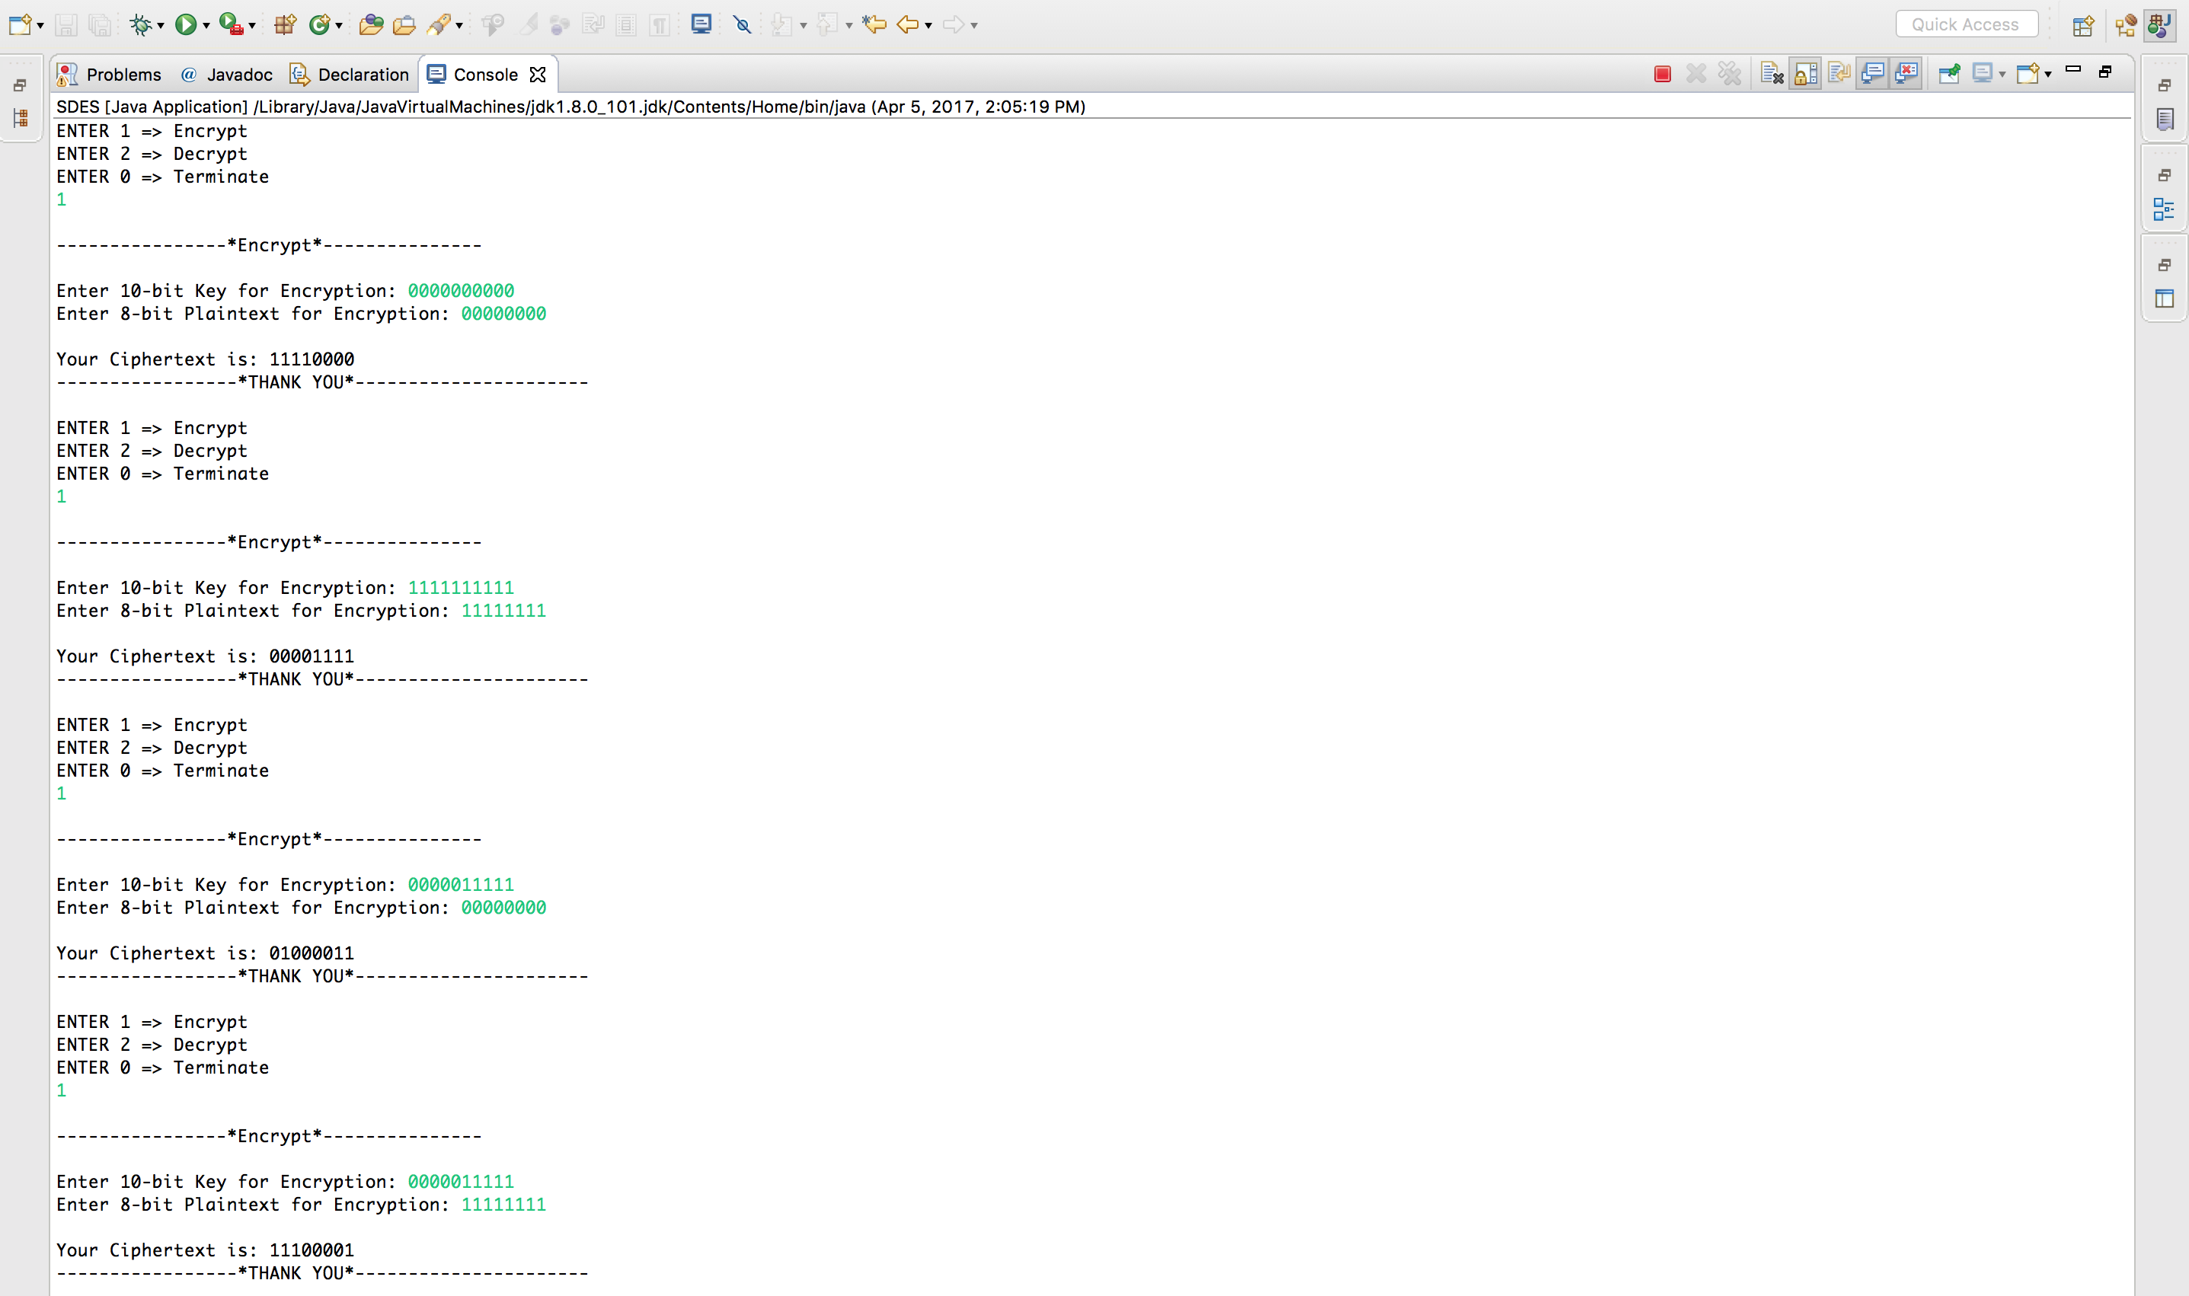

**1.1 SDES_Encrypt_Screen-shot**

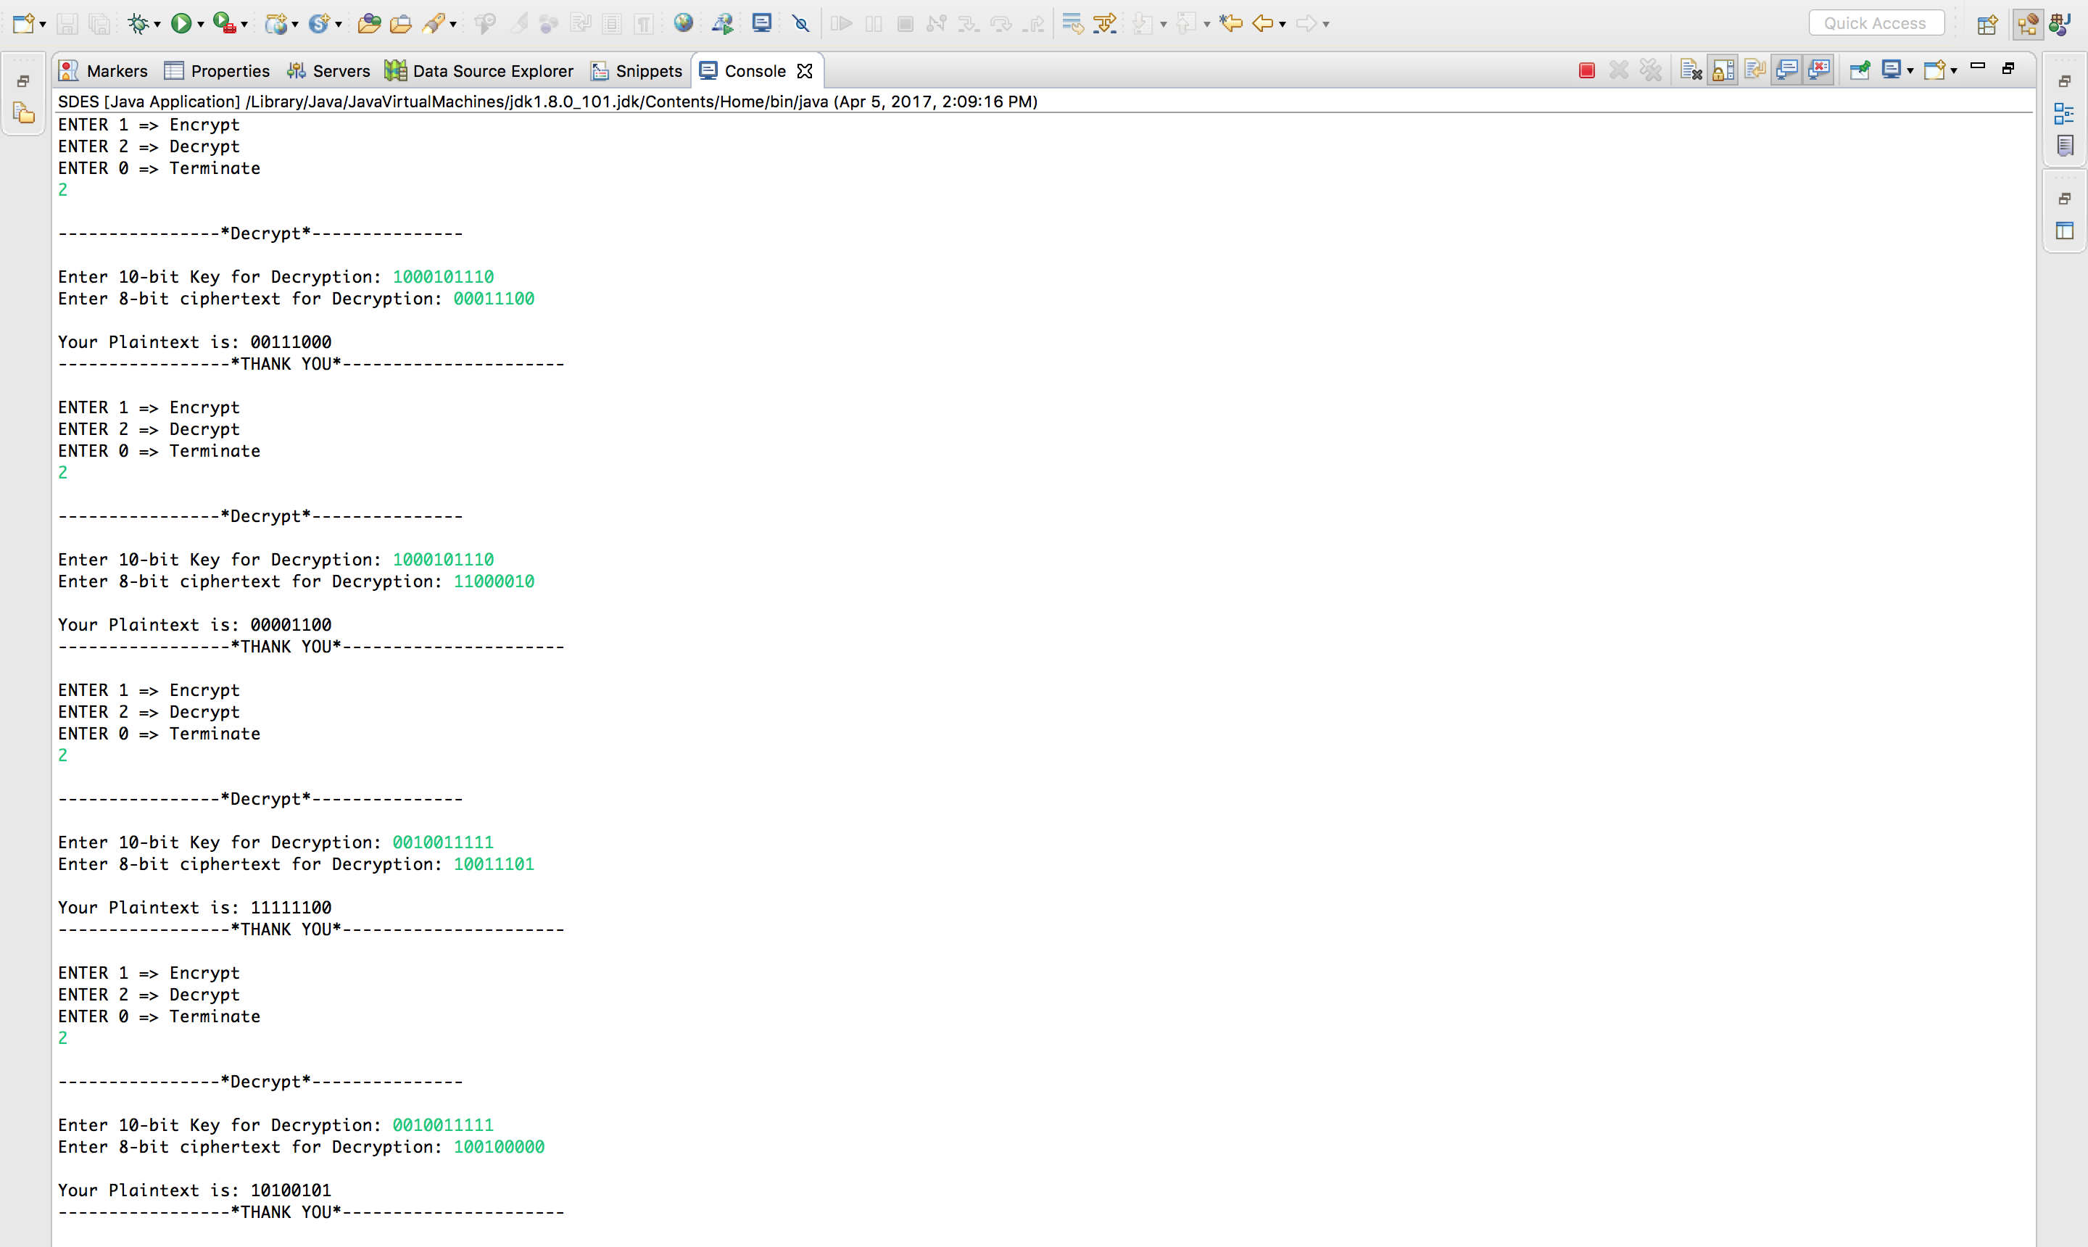

**1.2 SDES_Decrypt_Screen-shot**

|  |  |  |
| --- | --- | --- |
| Raw Key | Plaintext | Ciphertext |
| 0000000000 | 00000000 | 11110000 |
| 1111111111 | 11111111 | 00001111 |
| 0000011111 | 00000000 | 01000011 |
| 0000011111 | 11111111 | 11100001 |
| 1000101110 | 00111000 | 00011100 |
| 1000101110 | 00001100 | 11000010 |
| 0010011111 | 11111100 | 10011101 |
| 0010011111 | 10100101 | 10010000 |

**[SDES]**

**Part - 2 TripleSDES**

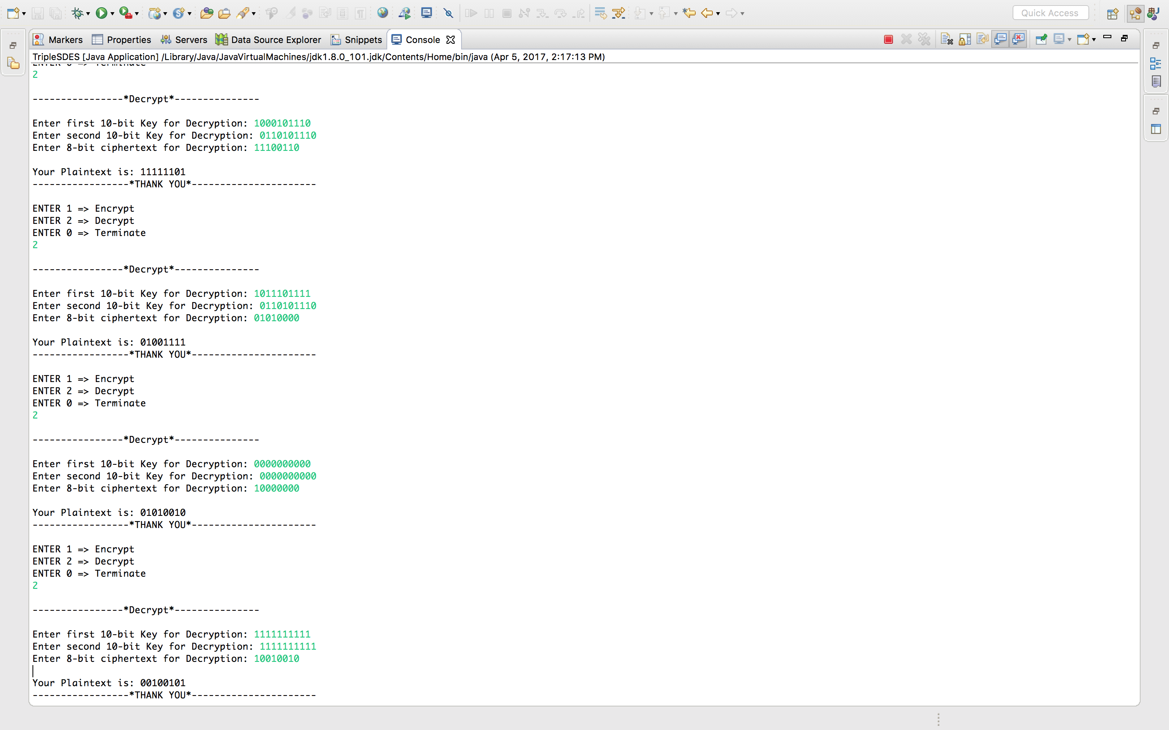

**2.1 TripleSDES_Decrypt _Screen-shot**

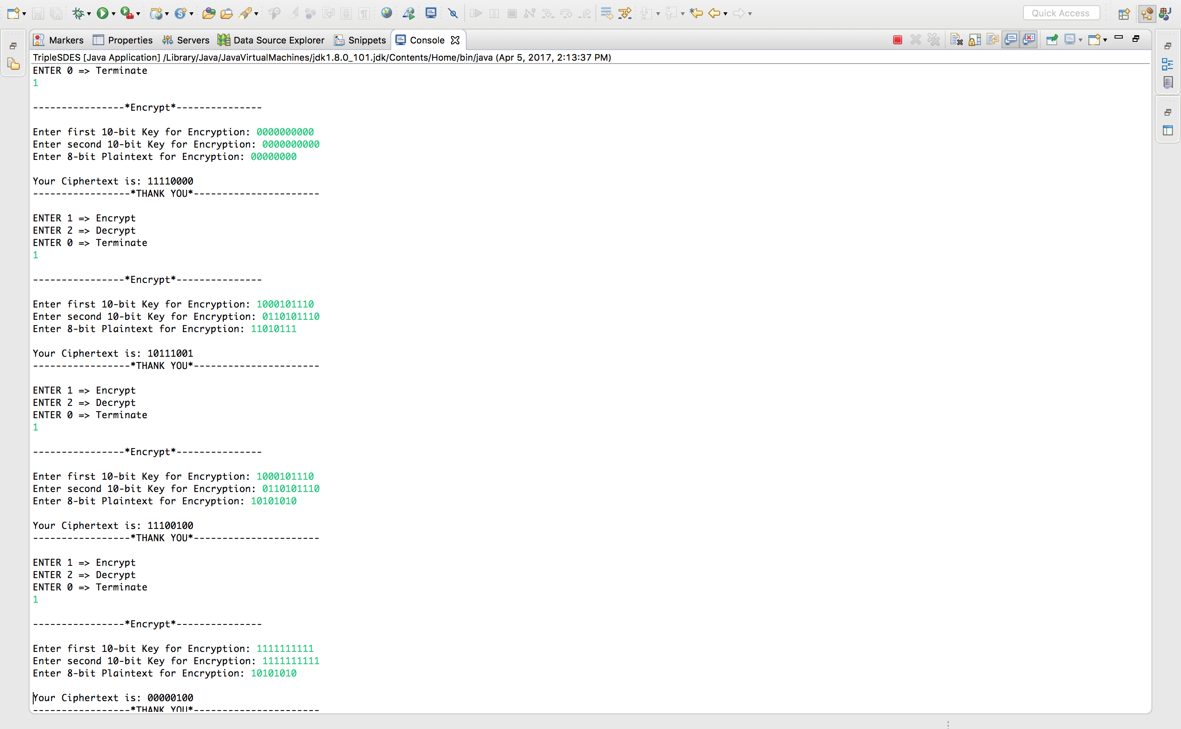

**2.2 TripleSDES_Encrypt_Screen-shot**

|  |  |  |  |
| --- | --- | --- | --- |
| Raw Key 1 | Raw Key | Plaintext | Ciphertext |
| 0000000000 | 0000000000 | 00000000 | 11110000 |
| 1000101110 | 1000101110 | 11010111 | 10111001 |
| 1000101110 | 1000101110 | 10101010 | 11100100 |
| 1111111111 | 1111111111 | 10101010 | 00000100 |
| 1000101110 | 0110101110 | 11111101 | 11100110 |
| 1011101111 | 0110101110 | 01001111 | 01010000 |
| 0000000000 | 0000000000 | 01010010 | 10000000 |
| 1111111111 | 1111111111 | 00100101 | 10010010 |

**[TripleSDES]**

**Part - 3 Cracking SDES and TripleSDES**

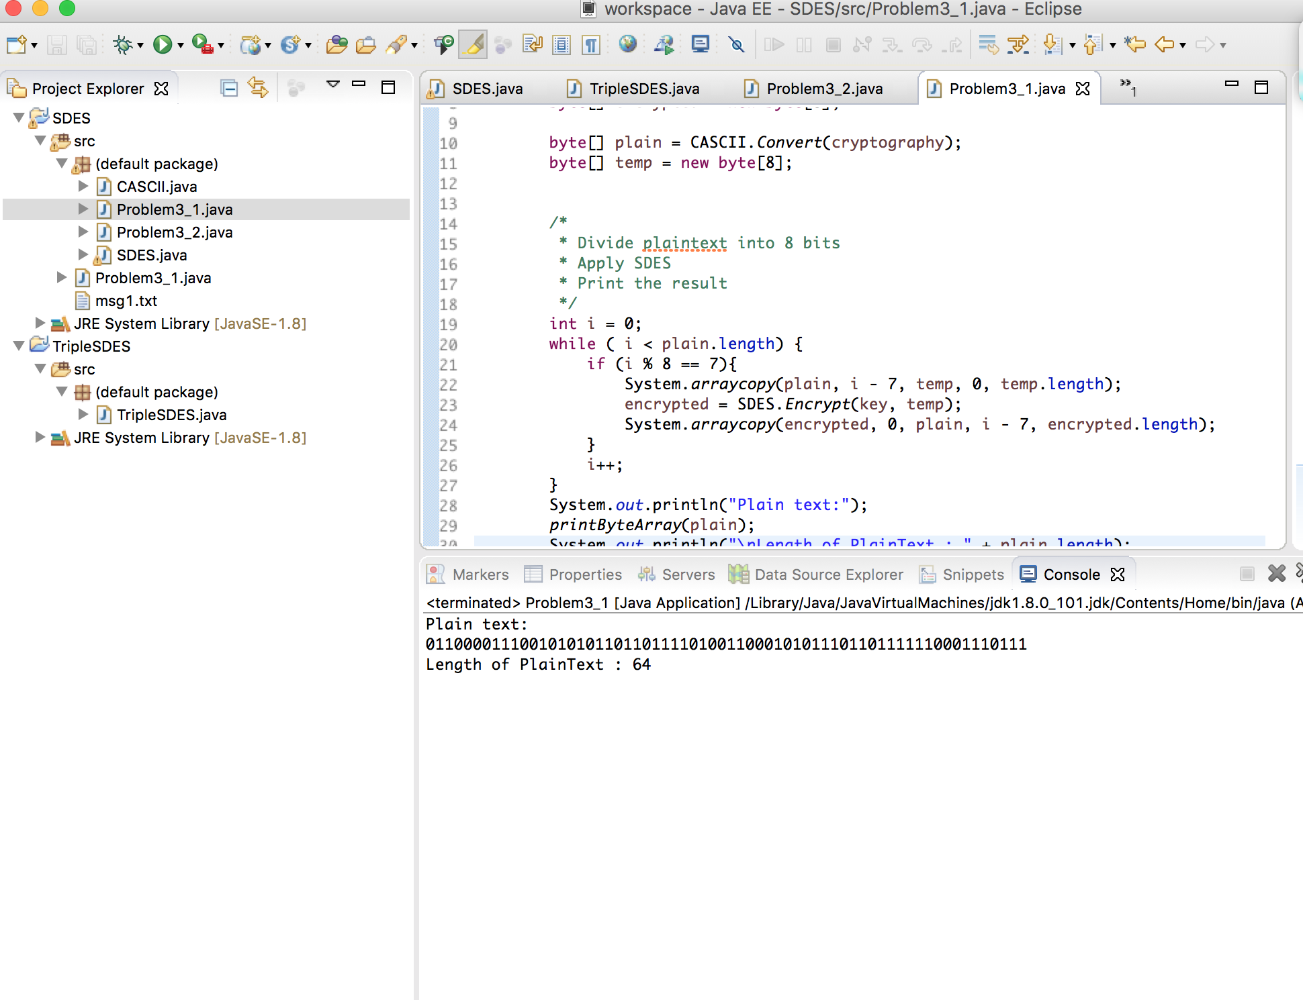

**[ 3.1 CASCII_SDES]**

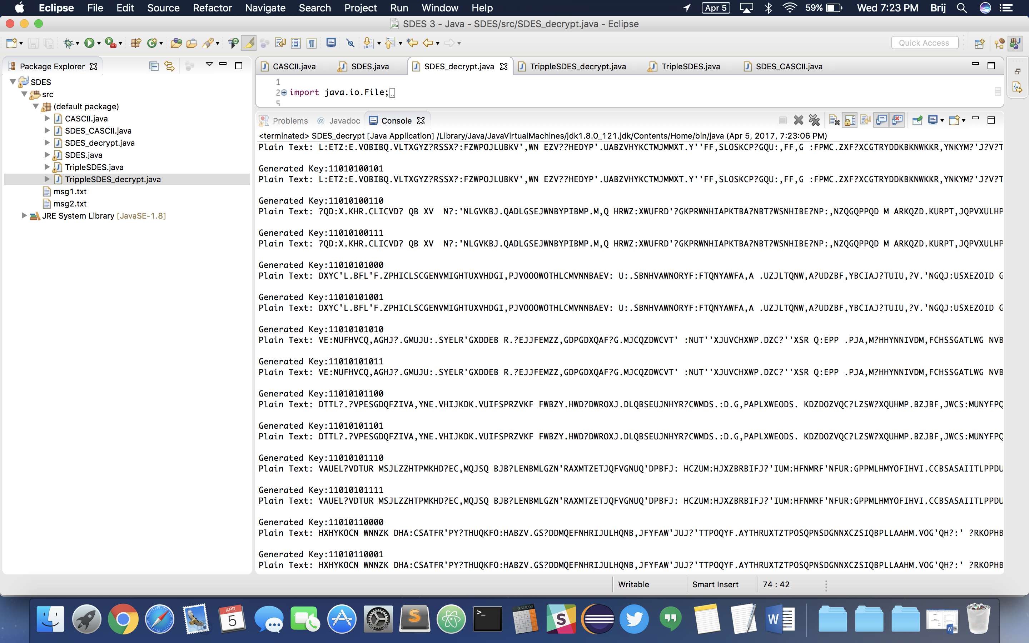

**[ 3.2 SDES_Decrypt]**

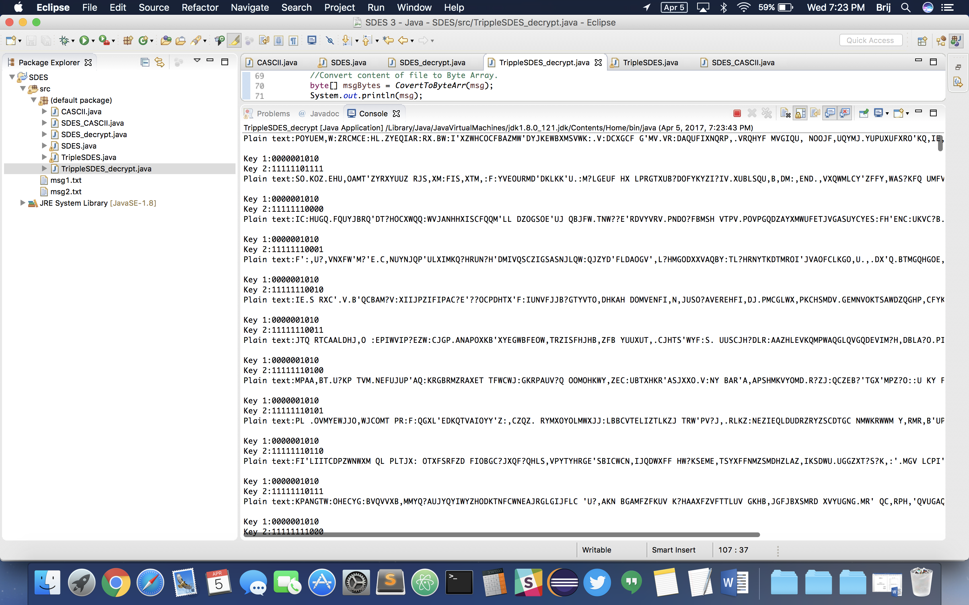

**[ 3.3 TrippleSDES_Decrypt]**